On_Me

Connor Larson

University of Missouri – Kansas City

Table of Contents
Vision Statement 3
Requirements 4
Product Backlog 5
Sprint #1 6
Review 6
Retrospective 6
Sprint #2 7
Review 7
Retrospective 7
Sprint #3 8
Review 8
Retrospective 8
Sprint #4 9
Review 9
Retrospective 9
Sprint #5 10
Review 10
Retrospective 10
Sprint #6 11
Review 11
Retrospective 11

Vision Statement
I will Create a mobile app that allows users to send another user a prepaid for token that allows them to buy an item off the menu at a restaurant. Users will be able to create accounts and check into bars/Restaurants this will trigger notifications alerting their other users if they choose to alert them. Additionally, users will be able to connect a credit card and select an item on the menu and pay for it for another user. This will be useful because it will allow users to securely buy their friend a drink at a bar all from inside an app. There will be a referral system for users who get other users to sign up as well as users who sign up restaurants. A later implementation will include a different view for restaurants who are signed up that allows them to track all transactions for the day in a meaningful way.

Requirements
A discussion of what your application is required to have in functionality. It should identify user roles and goals/actions, and what the key features of the app should be.
Actor | Goal
User | Be able to check in to restaurant based on GPS coordinates  Be able to add other users to friend network  Be able to refer other users/ Restaurants  Be able to purchase an item from restaurant’s menu and send securely to another user  Be able to update profile
Restaurant User | Able to See all transactions for the day  Able to Run statistical analysis on the days/weeks/months/years data  Able to Send out advertisements to users opted into service.  Able to Add and edit menu
Admin User | Be able to see All transactions globally

Product Backlog
This will be updated throughout the semester as new PBIs are added, larger items are broken into smaller ones, and completed items removed.

Story ID | Story | Story Points  (in est. hours) | Priority | Status
00 | Learn Android studio and how to use it | 8 | 0 | Done
01 | Build Basic UI and Navigation  - Home Screen  - Friends Screen  - Favorites Screen  - Credits Screen  - History Screen  - Profile Screen | 2 | 1 | Done
02 | Research what Backend to use  - Mysql Server hosted on raspberry pi for now. | 2-3 | 2 | Done
03 | Implement backend.  - Set up Users table  - Set up Drinks Table  - Set up Bars Table  - Set up Transaction Table  - Set up Friends Table  - Set up Restaurants Table  Connect app to the backend. | 3-5 | 3 | done
04 | Build Login Screen | 3-5 | 4 | Done
05 | Build user Profile page  - Pull Data from database  - Update profile page based on that data  - Set up Scroll views | 3-5 | 5 | Done
05.1 | Add functionality to buttons with modals on profile page | 4 | 5.1 | Not done
06 | Build Home Page  - MAP fragment using google maps  - Clicking them will bring up restaurant page | 2-3 | 6 | Done
06.1 | Add functionality to select place button that will pop up a modal to allow user to select a drink to send and then send it to the user. | 4-5 | 6.1 | done
07 | Build Friends page  - Scroll view that pulls data from database of all friends | 2-3 | 7 | done
07.1 | Clicking on them will bring up the users profile page  Add friend button working | 2-3 | 7.1 | Not done
08 | Build Favorites Page  - Pull data from database and populate the 2 scroll views with clickable items | 3 | 8 | done
08.1 | Add functionality to add delete and edit tables with popup screens on favorites page. | 3 | 8.1 | Not done
09 | Build the select item to send page That comes from the Restaurant selection page.  - New activity that will display of the Restaurant profile.  - Will have their menu on there.  - Selecting an item will allow user to pick another user to send the drink to. | 4 | 9 | done
10 | Build the redemption screen that will display after someone has sent you a drink  - Alert user they have been sent a drink some sort of listener | 5 | 10 | Not done
11 | Build History page  - Scroll view that will display all transactions from user account | 2 | 11 | done
12 | Research and then Implement Credit card pay screen/ Hook into Venmo | 3-4 | 12 | Not done
13 | Build Master admin screen that shows all users and some basic data numbers | 4-5 | 13 | Not done
14 | Build screen to allow restaurant to upload menu | 4 | 14 | Not done
15 | Build component to Allow Restaurant to send out promos to registered users | 3 | 15 | Not done
16 | Build component that allows restaurant to run analytics on data. | 4 | 16 | Not done

Sprint #1

Sprint Backlog
Story ID | Story / Task | Estimated  Hours | Actual  Hours
01 | Build Basic UI and Naviagtion  - Nav Bar with functionality  - Each page set up with Basic components in place | 2 | 6
02 | Research what Backend to use | 2-3 | 6
00 | Learn Android Studio | 8 | 8

Review

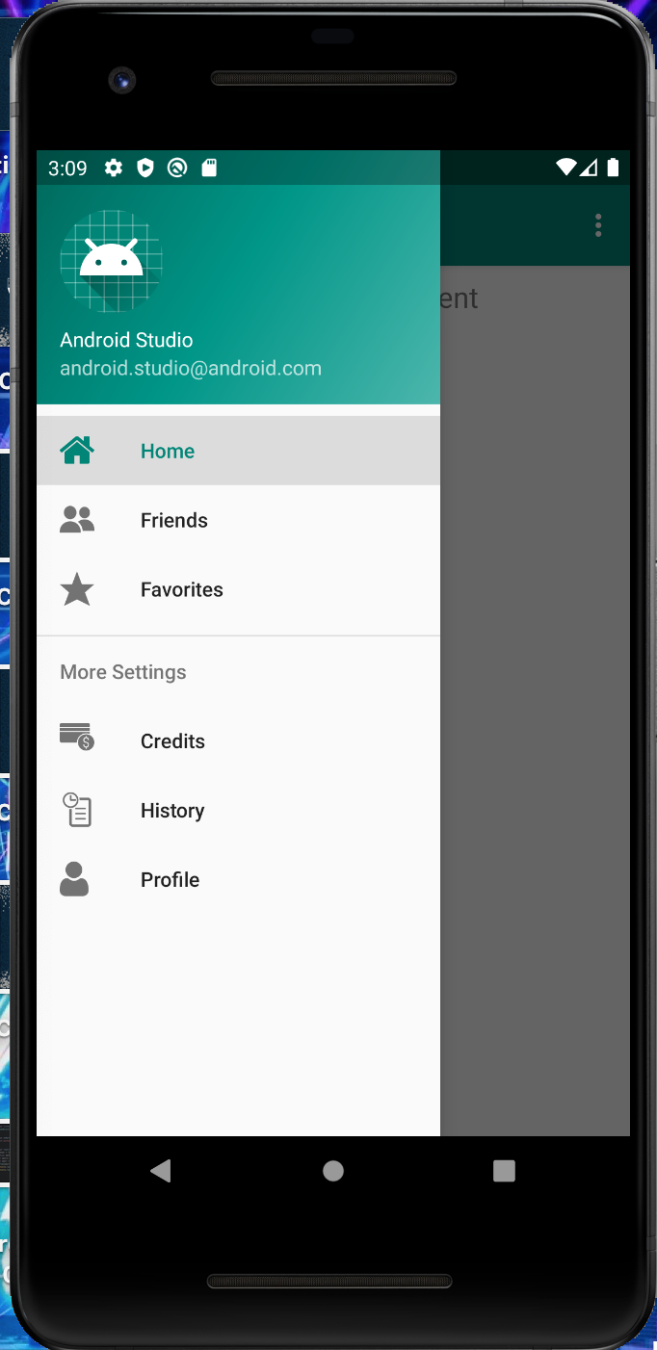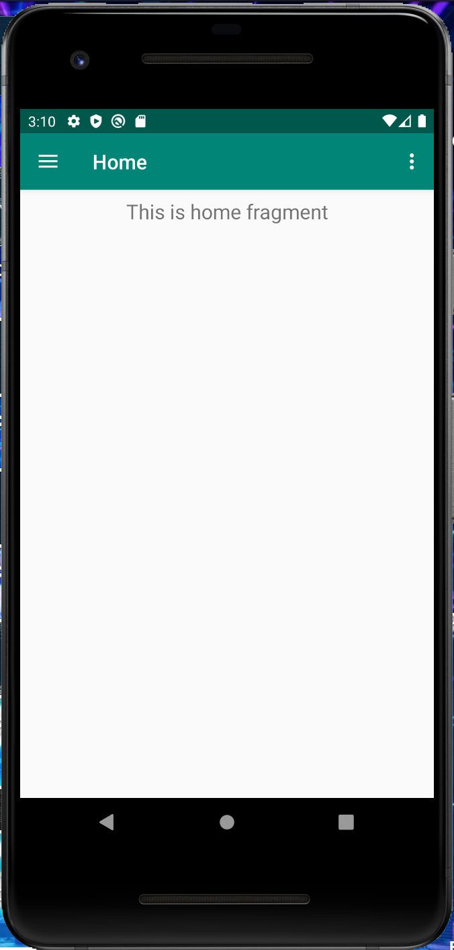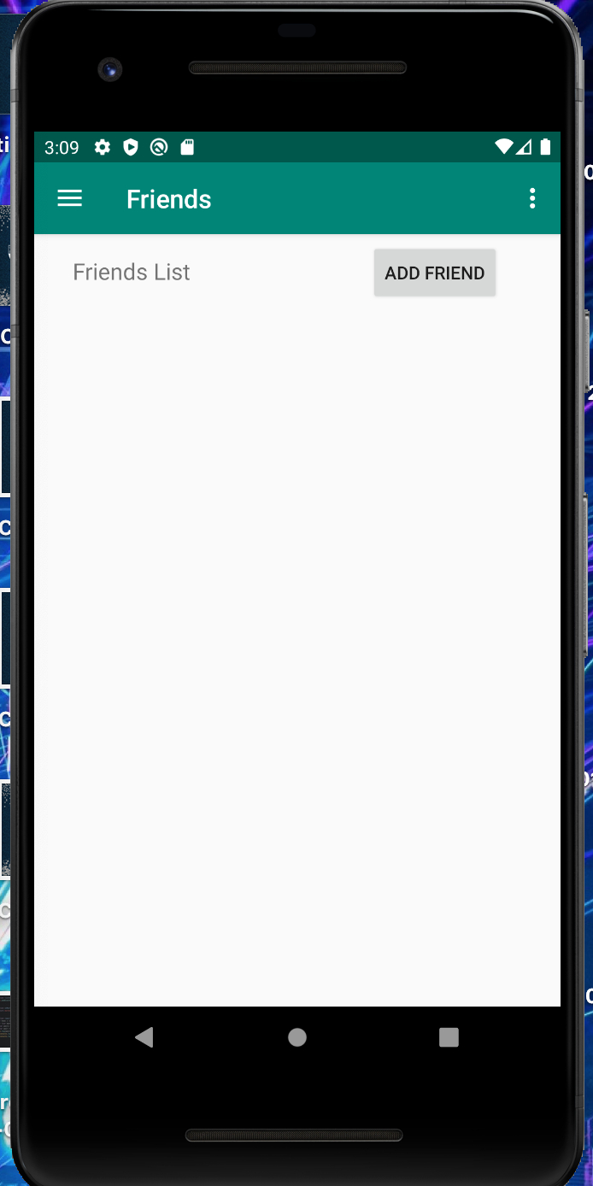

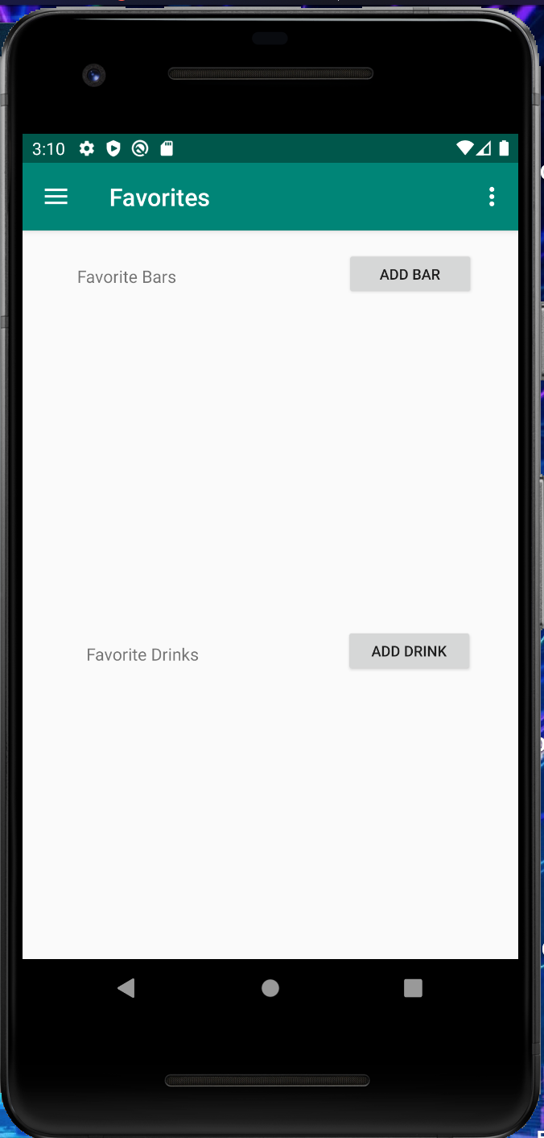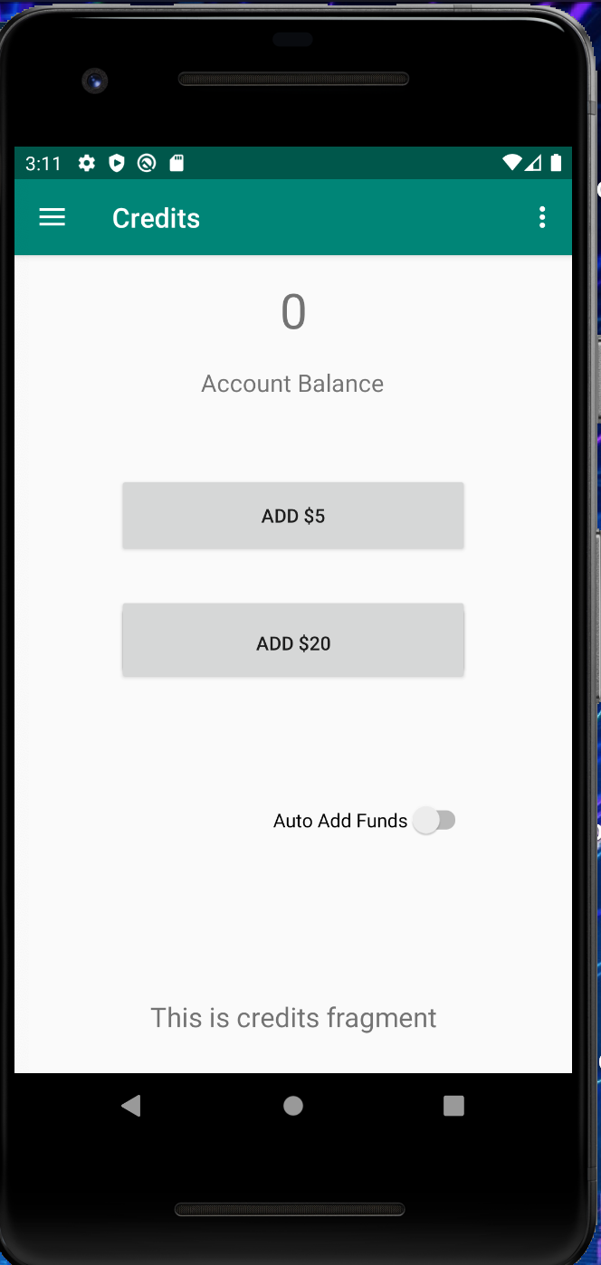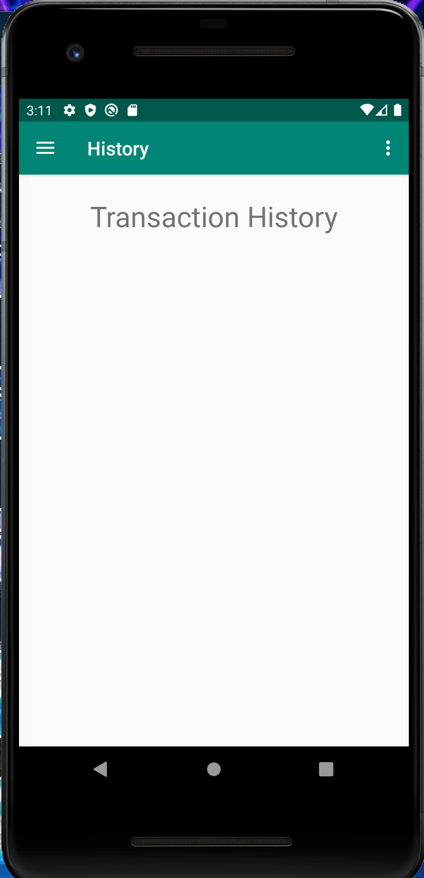

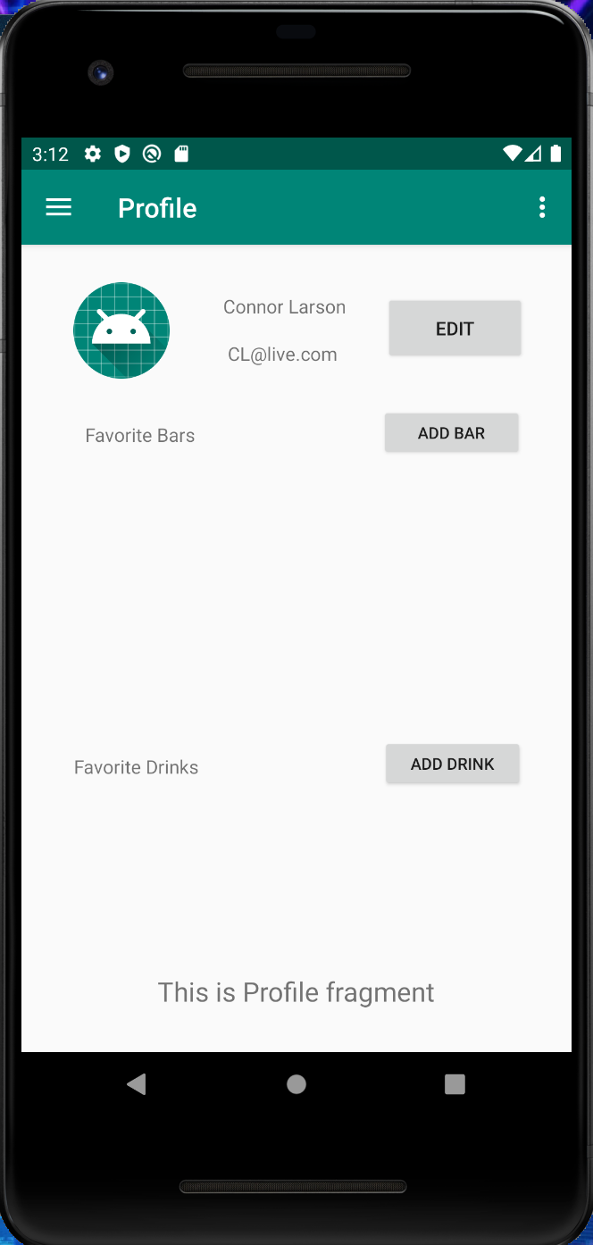

For this iteration I first had to learn how to program in android studio and what features were available for me to use. I settled on a navbar navigation and started building from there. I created basic shell pages where my content will live for the app. I then went in and hooked up the navigation functionality so that a user can get around my app. After this was complete I started doing research into what database I should use for my application.

With this just being a class and not a real-world product I settled on a MySQL database that is hosted on a raspberry pi at my house. After this is created and port forwarded I should be able to hit the database externally and make updates via my app. All of the applications data will live in this database and then I will have tables for each of the different sections of data.

Retrospective
The setup and learning process took a lot longer than I thought. I spent hours watching videos on YouTube on different aspects of the language. The actual coding part was not super hard but did take a little bit of time to understand how fragments works. The more I write the more comfortable I get with the language so I assume in the future I will need to switch back and forth between files much less which took up a lot of time.
For the next sprint I reordered my backlog based on what I accomplished this sprint and what I thought would be most important for the next sprint. I am learning that there is a lot that I did not plan for so after writing the code I discovered some more pieces that will need to be added. My Main goal for the next sprint is the database setup because this is crucial to how my app will get and update data. After that is done I plan to tackle the Login page, profile page and potentially the home page if time allows.

Sprint #2

Sprint Backlog
Story ID | Story / Task | Estimated  Hours | Actual  Hours
03 | Implement backend.  Set up hosting  - Set up Users table  - Set up Drinks Table  - Set up Bars Table  - Set up Transaction Table  - Set up Friends Table  - Set up Restaurants Table | 3-5 | 10
04 | Build Login Screen  For now basic login. Authentication to be added later | 3-5 | 8
05 | Build user Profile page  - Pull Data from database  - Update profile page based on that data  - Set up Scroll views | 3-5 | 0

Review
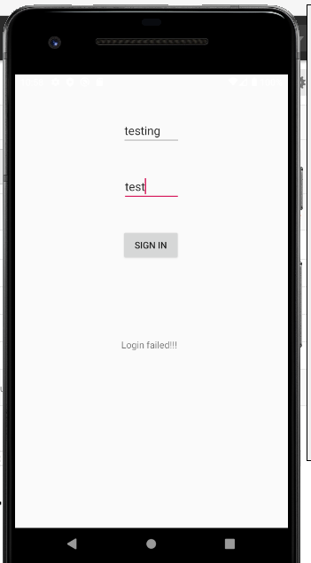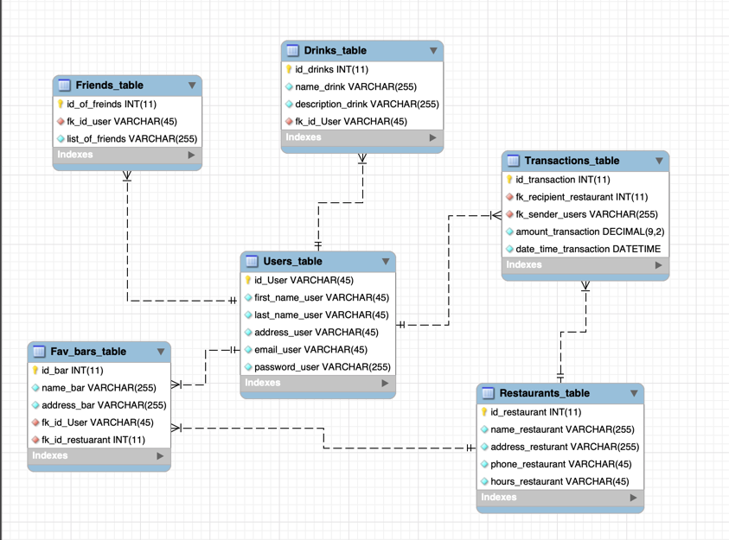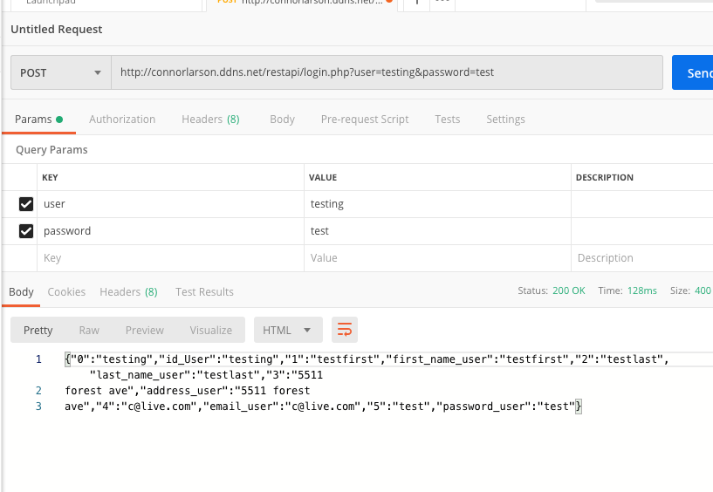
For this iteration I first started with the backend as it was the next step before everything else would work. Originally, I had planned to use my raspberry pi with a simple apache webserver running on it. Now this was my first time ever attempting to do this and I assumed it was not working because I could not connect to the database from mysql workbench. After several hours of messing with that I decided to try and set up a database on AWS and then use that. I had greater success as I was able to host and then connect to my database with mysql workbench. This is where I built my tables. With the tables all built I went to try and connect my app to my database. This is where I ran into the most trouble. I did not realize that you could not connect the app directly to the database and instead a middle REST API was needed. Well I couldn’t figure out how to added that to my AWS database so I went back to my raspberry pi which I then learned was actually set up correctly the first time. I recreated my tables in this database and then went to learning what a REST API is. This in itself took a long time because I had never coded in PHP. After finally getting something that works and was testable in postman, I went to my app and built a login activity. I then tried to create the post method that would hit my API. However, something is not working and it has created a road block for me. Somehow my parameters are not getting to the API correctly and it is failing. So, the plan for the next sprint is to figure that out and then be able to catch up on the other work I meant to do this sprint.

Edit: After spending today I was able to fix the issue and finish the login page successfully hitting my database.
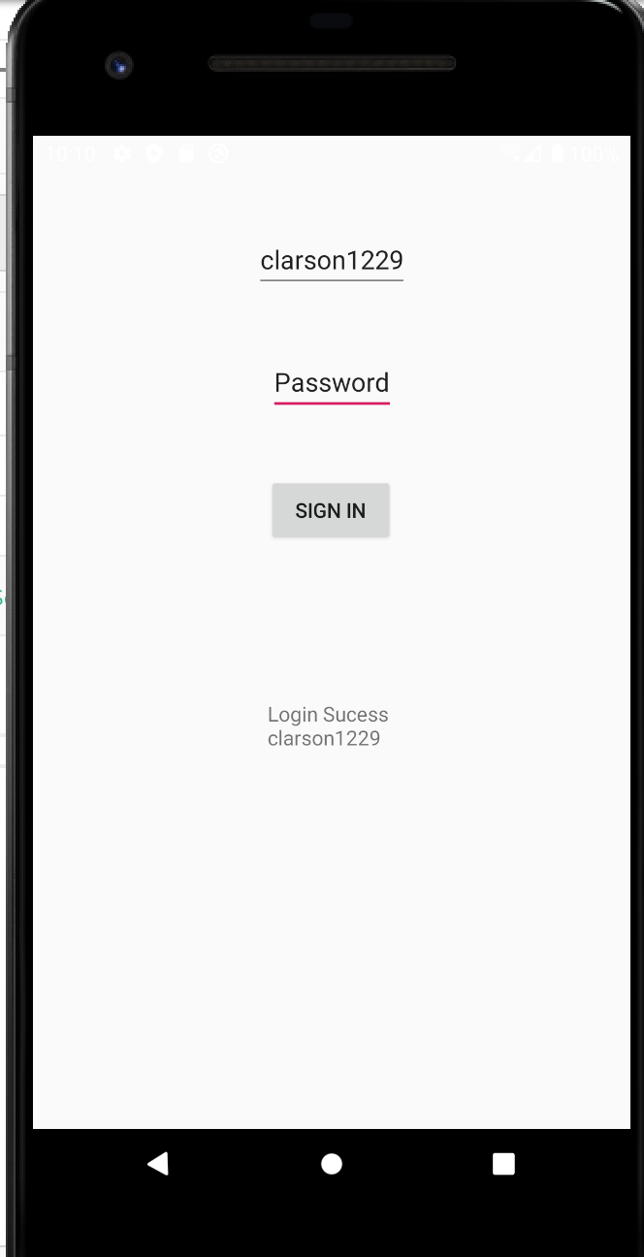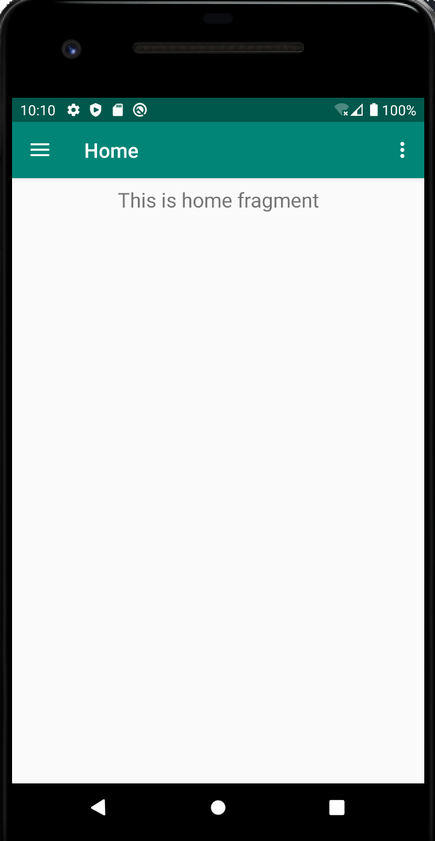

Retrospective
I definitely picked a project that was a lot harder than needed. Involving the use of an external database for multiple users is over complicated for this project but I feel at this point its kind of too late. So, I have to push on and figure out this road block. I spent a lot of time watching random tutorials hoping something would help and eventually they did so I think for the next sprint I will spend a lot more time doing that before I get into the code as I saw it was confusing going back and forth.

Sprint #3

Sprint Backlog
Story ID | Story / Task | Estimated  Hours | Actual  Hours
04 | Finish Login Screen.  Figure out issue with Post method | 3-5 | 6
05 | Build user Profile page  - Pull Data from database  - Update profile page based on that data  - Set up Scroll views | 3-5 | 3
06 | Build Home Page  - MAP fragment using google maps  - Clicking them will bring up restaurant page | 2-3 | 7
08 | Build Favorites Page  •Pull data from database and populate the 2 scroll views with clickable items | 2-3 | 1

Review
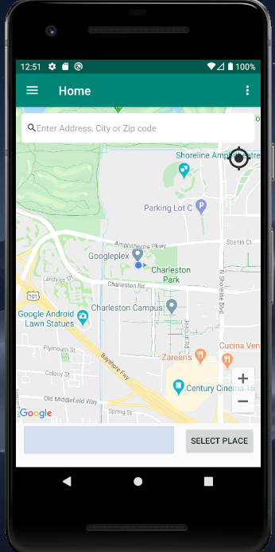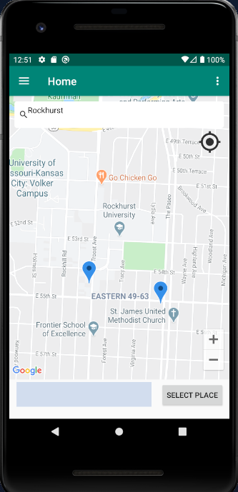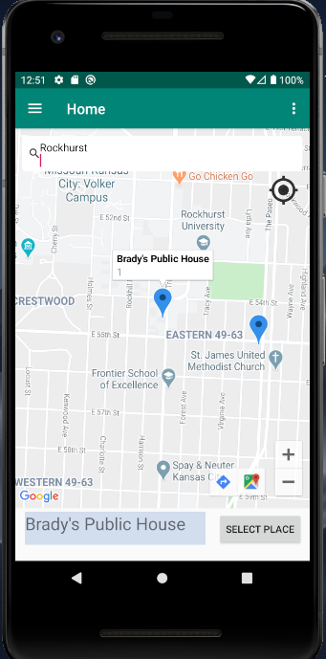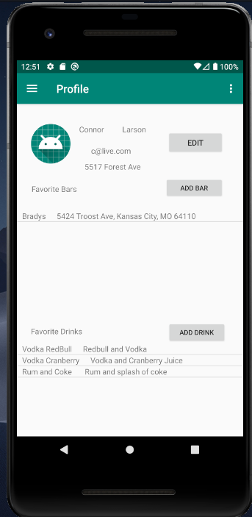
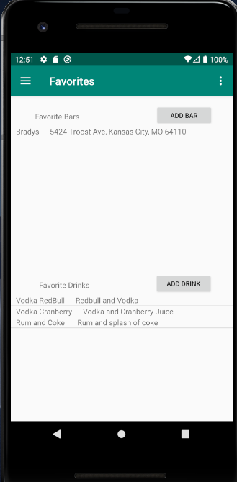
For this sprint my main focus was the home page, profile page and favorites page. Which are shown above in the screenshots. To have my app be able to pull in data from the external database I had to write API’s to get the data which are also posted in my repo. After I wrote getters for the profile info, Restaurants info, Fav drinks info, and Fav bars info I was able to start writing the java code to display the information. The map displayed on the page uses google maps via the API they have set up. I had to generate credentials for app and then it was able to display. One thing that I need to investigate is that my emulator when it gets the devices location thinks it is in California. I need to switch my emulator to use my location instead. The points on the map need to be customized but that will happen in a future iteration dedicated to just style. All of the points on the map come from database and then after some processing are displayed on the map. The same is true for the information being displayed on the profile and favorites page. The buttons do not work yet but I plan to do that In the next iteration.

Retrospective
For this sprint things went well after I watched a bunch of tutorials. I am finding that by watching them first I am able to understand what is happening then it is much easier to change the example code to my own intended use. I had a bit of a time with the post statements but after much trial and error it became a lot easier to write. I am also finding that naming conventions will be very important in this app as it uses ID’s for everything. So, as I go forward I plan to use more specific names in both my UI components and backend variables. For the future Iteration I plan to start sooner so that I am not as rushed.

Sprint #4
Sprint Backlog
Story ID | Story / Task | Estimated  Hours | Actual  Hours
07 | Build Friends page  - Scroll view that pulls data from database of all friends  - Clicking on them will bring up the users profile page | 2-3 | 2
06.1 | Add functionality to select place button that will pop up a modal to allow user to select a drink to send and then send it to the user. (connected to story 09) | 4-5 | 4
09 | Build the select item to send page That comes from the Restaurant selection page.  - New activity that will display of the Restaurant profile.  - Will have their menu on there.  - Selecting an item will allow user to pick another user to send the drink to. | 4 | 3
11 | Build History page  - Scroll view that will display all transactions from user account | 2 | 3
08.1 | Add functionality to add delete and edit tables with popup screens on favorites page.  - Update API’s  - Delete API’s  - Add API’s | 6 | Partly done

Review
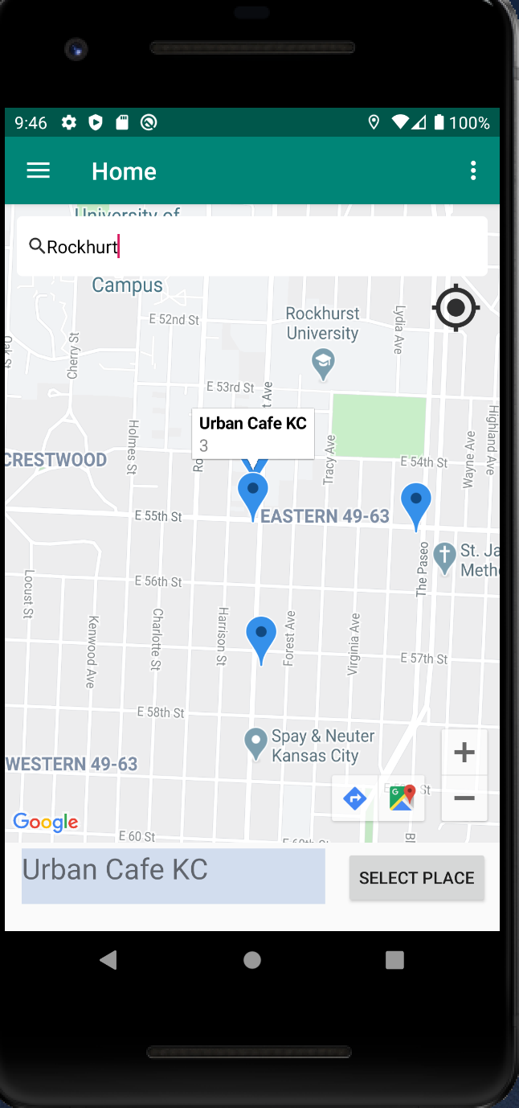

Clicking the Select place button after selecting a restaurant will pull up the next screen.

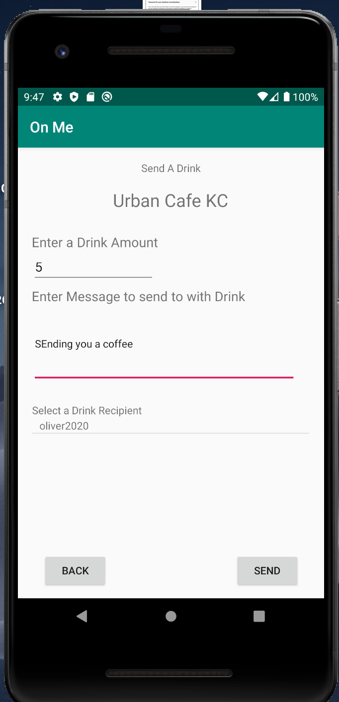This Screen allows the user to enter a dollar amount that the want to send to another user. They can enter a message along with it, They then select a recipient from one of their friends from their friends list. Pressing back closes the screen and nothing is done. Pressing send sends the transaction to the database. This takes the user back to the map.

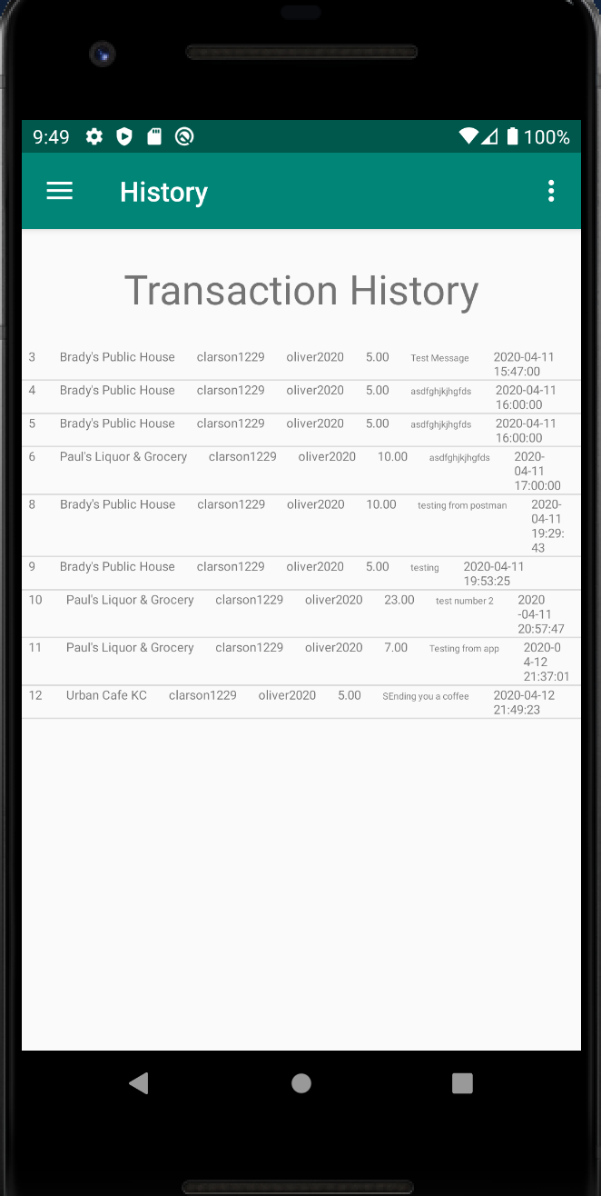This is the transactions or history page. It pulls transactions from the database that the logged in user either sent or was sent. The table itself needs styling still.

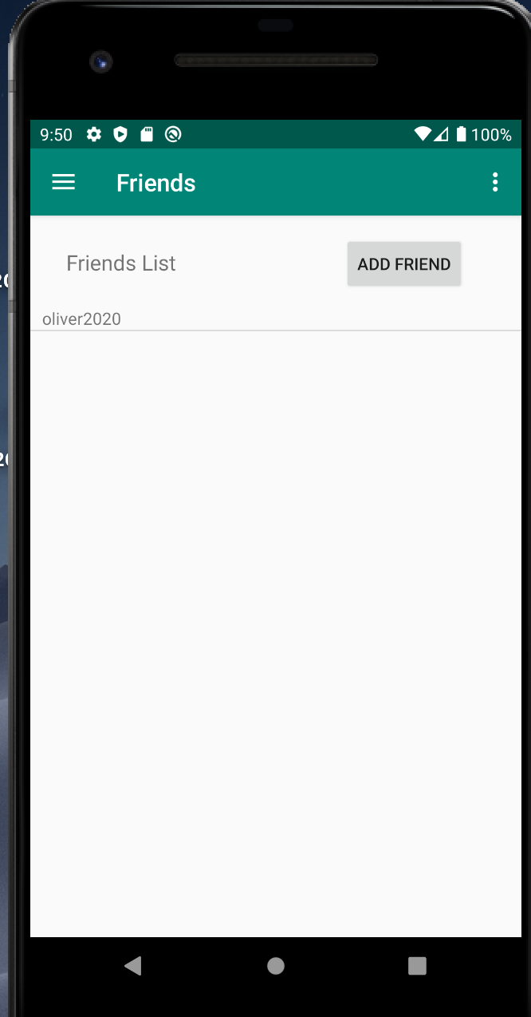The friends tab now pulls in added friends.

Additionally for this sprint I wrote the Create APis for Transactions, Fav drinks, friends, and fav bars. The only things that I had planned on doing but did not get to was fully connecting the add buttons to the database. I need to learn how to create a popup modal that will live on top of the page for the user to enter data. Then I just have to send that in a post statement and I should be good so I believe once I get one of them done the other 3 should not take me a long time.

Retrospective
For this sprint things went well overall. I am getting better at writing these API’s but so far that seems to be the slowest thing to develop. I am learning the little tricks of how to use android studio and that seems to be helping as well. One tutorial that I watched used Log statements to be able to see exactly what the app is doing and by adding those to my own project debugging has become much easier. I plan to continue doing this.

Sprint #5

Sprint Backlog
Story ID | Story / Task | Estimated  Hours | Actual  Hours
07.1 | Clicking on them will bring up the users profile page | 1
08.1 | Add functionality to add delete and edit tables with popup screens on favorites page.  - Update API’s  - Delete API’s | 4
05.1 | Add functionality to buttons with modals on profile page  - Update API | 3
10 | Build the redemption screen that will display after someone has sent you a drink  - Alert user they have been sent a drink some sort of listener | 5

Review

[Screenshots, etc go here. This is where you discuss the product, describing what was done this sprint (potentially shippable product increment) and what was planned for the sprint but was not done. ]

Retrospective
[This is where you discuss the process. What went well (and are you planning to do more of that?) What didn’t go so well (and do you have a way to do less of that)? What changes are you planning to make in how you plan & carry out the next sprint?]

Sprint #6

Sprint Backlog
Story ID | Story / Task | Estimated  Hours | Actual  Hours

Review

[Screenshots, etc go here. This is where you discuss the product, describing what was done this sprint (potentially shippable product increment) and what was planned for the sprint but was not done. ]

Retrospective
[This is where you discuss the process. What went well (and are you planning to do more of that?) What didn’t go so well (and do you have a way to do less of that)? What changes are you planning to make in how you plan & carry out the next sprint?]

